Travelling to clinic may pose financial challenges for some families and patients. The Hemophilia Program of British Columbia recognizes this and has put together a booklet that highlights discounts and financial assistance that is available for travel. Ask your clinic for your copy of the “Getting There” – The Travel, Accommodation and Transportation Resource Guide.

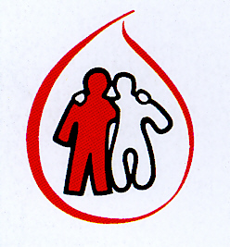

Hemophilia Program of British Columbia

“Getting There”

The Travel, Accommodation and Transportation Resource Guide



This travel resource guide was made possible by an educational grant from Baxter Canada.

